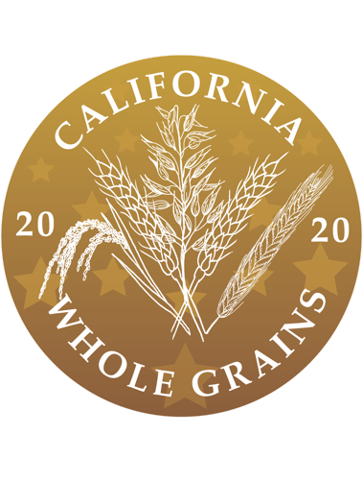 | Celebrating California Whole Grains 2020  &  International Whole Grain Day 2020  All day California Zoom event starting at 9.00 am  Thursday, November 19, 2020  Click here for link to California Zoom event

Enthusiasm abounds in California for whole grain foods, genuine 100% whole grain foods: bread, corn tortillas, roti, pasta, brown rice, teff injera, couscous, and much more.
Our day-long streaming Zoom interviews on November 19, will showcase just 30 or so of the many who make and enjoy genuine 100% whole grain foods in California. It’s time to set the record straight on whole grain food production and preferences.

Celebrating California Whole Grains 2020. Click here for link to full program.

International Whole Grain Day 2020. Click here for link to activities.

Presented by
California Wheat Commission
Whole Grain Connection
Golden State Grains

